|  |  |
| --- | --- |
| **download** | **University of Sargodha, Lahore Campus**  Department of CS & IT  Week 1  **(Spring 2018)** |

|  |  |  |
| --- | --- | --- |
| Course: | **Object Oriented Programming** | Date: |
| Course Code: | CMP-2124 | Lab Engineer: Saqib Ali Ahmad |

BSCS-F17-LC-070

Khuram Irshaad

Name: ____________________________________ Roll No: ________________________

## Lab Tasks :

## Q1:

**Q2:**

**Q3:**

**Q4:**

**Q5:**

**Lab Grading Sheet :**

|  |  |  |  |
| --- | --- | --- | --- |
| **Task** | **Max Marks** | **Obtained Marks** | **Comments(*if any*)** |
| 1. |  |  |  |
| 2. |  |  |  |
| 3. |  |  |  |
| 4. |  |  |  |
| 5. |  |  |  |
| **Total** |  |  | **Signature** |

**Week 1**

**1-Program Code:**

**#include<iostream>**

**using namespace std;**

**class A{**

**private:**

**int a;**

**public:**

**A(){**

**a=5;**

**}**

**friend class oop;**

**};**

**class oop{**

**public:**

**void show(A b)**

**{**

**cout<<"b="<<b.a;**

**}**

**};**

**int main(){**

**A c;**

**oop d;**

**d.show(c); }**

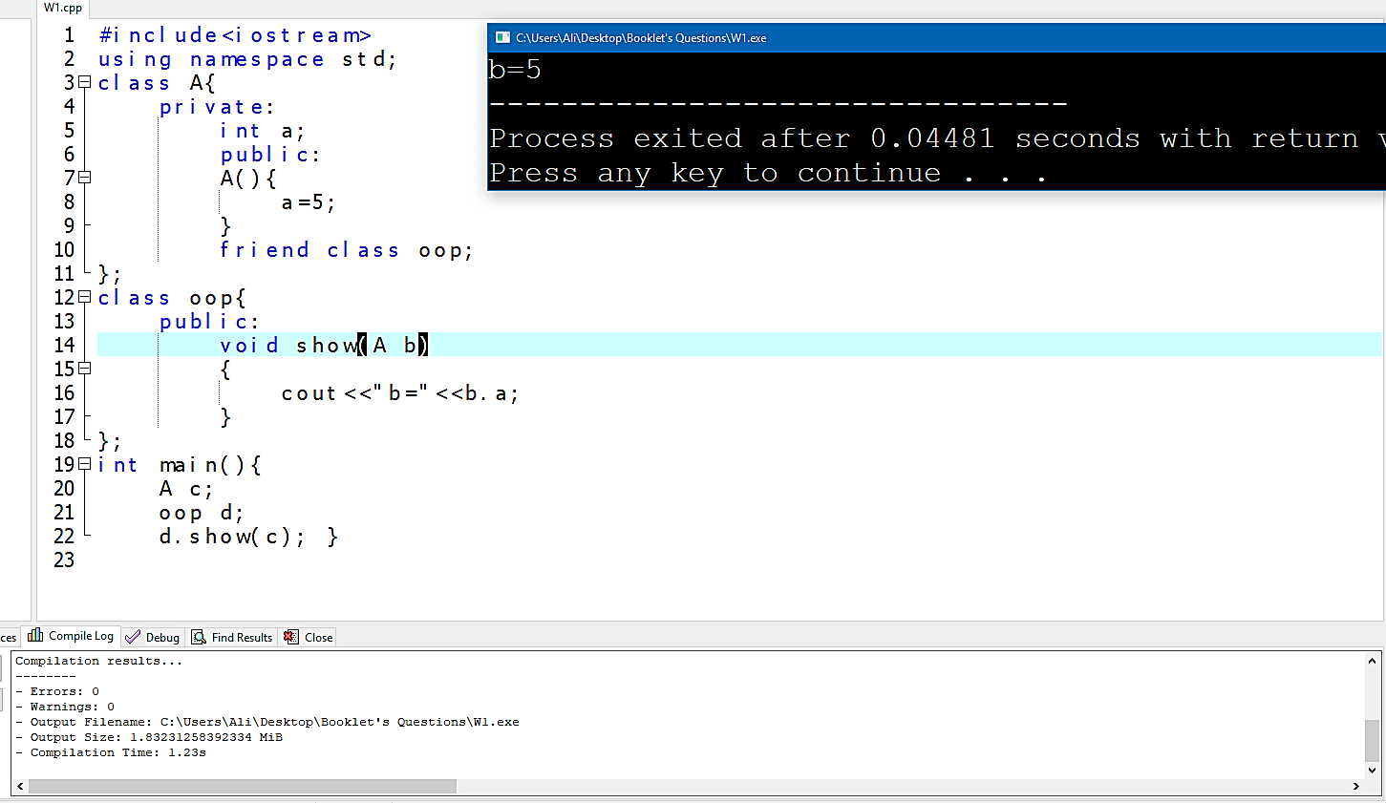**Output:**

**2-Program:**

**#include<iostream>**

**using namespace std;**

**class A{**

**private:**

**int id,price,i;**

**public:**

**void input(A Arr[]){**

**for(i=0;i<5;i++){**

**cout<<"enter id of book";**

**cin>>Arr[i].id;**

**cout<<"enter the price of book";**

**cin>>Arr[i].price;**

**}**

**}**

**void show(A Arr[]){**

**int a,max;**

**for(i=0;i<5;i++){**

**if(Arr[i].price>Arr[0].price){**

**max=Arr[i].price;**

**a=i;**

**}**

**else{**

**max=Arr[0].price;**

**a=0;**

**}**

**}**

**cout<<"most expensive book has a price"<<Arr[a].price<<endl<<"and id"<<Arr[a].id;**

**}**

**};**

**int main(){**

**A Arr[5];**

**Arr[5].input(Arr);**

**Arr[5].show(Arr);**

**}**

**Output**

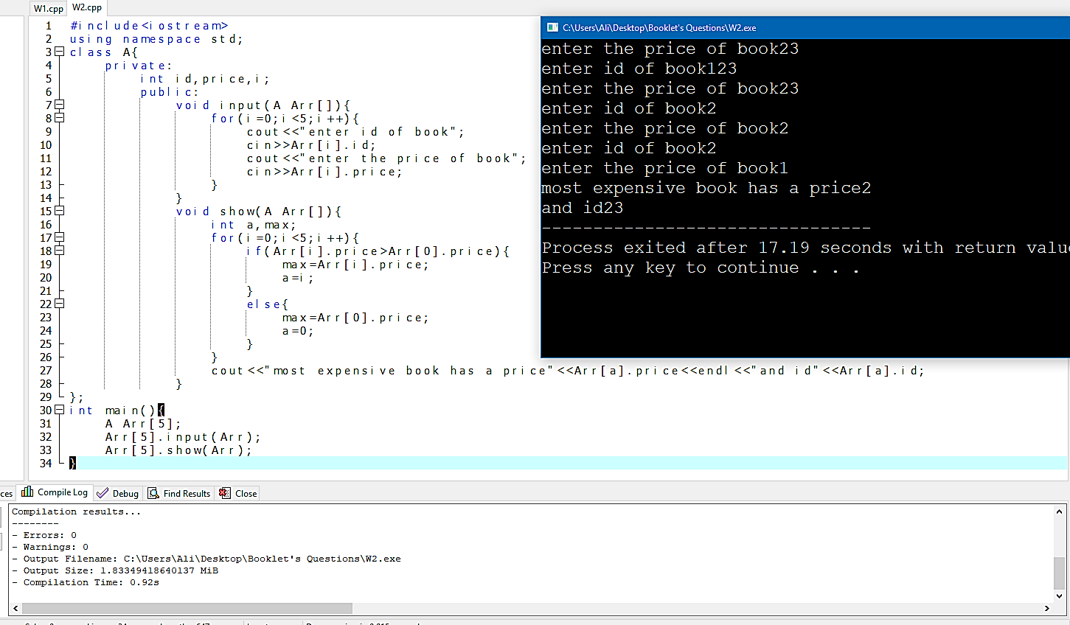

**Week 2**

**1-Program:**

**#include<iostream>**

**using namespace std;**

**class A{**

**private:**

**int m=0;**

**protected:**

**int n=0;**

**public:**

**int p=0;**

**void B()**

**{**

**m++;**

**n++;**

**p++;**

**}**

**};**

**class oop:public A{**

**public:**

**void show(){**

**cout<<n;**

**cout<<p;**

**}**

**};**

**int main(){**

**oop o1;**

**o1.show();**

**o1.B();**

**o1.show();**

**}**

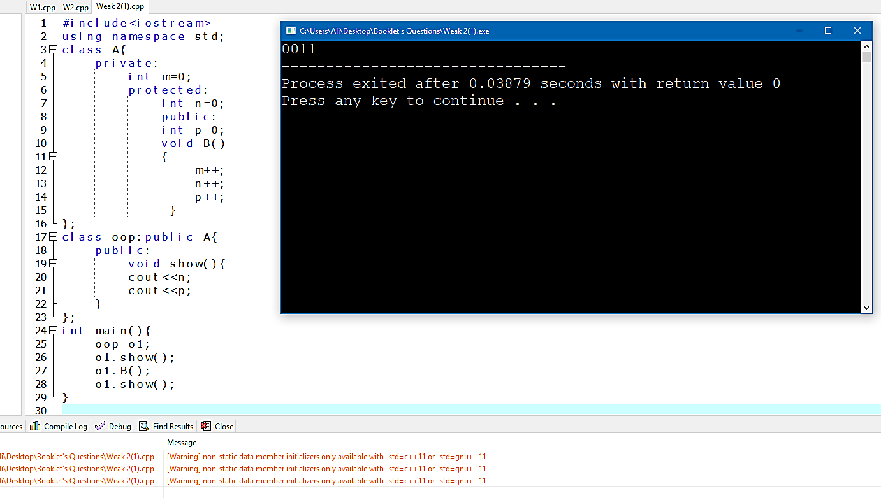**Output:**

**2-Program:**

**#include<iostream>**

**using namespace std;**

**class A{**

**private:**

**int m=0;**

**protected:**

**int n=0;**

**public:**

**int p=0;**

**void B()**

**{**

**m++;**

**n++;**

**p++;**

**}**

**};**

**class oop:private A{**

**public:**

**void show(){**

**cout<<n;**

**cout<<p;**

**}**

**};**

**int main(){**

**A o1;**

**oop o2;**

**o2.show();**

**o1.B();**

**o2.show();**

**}**

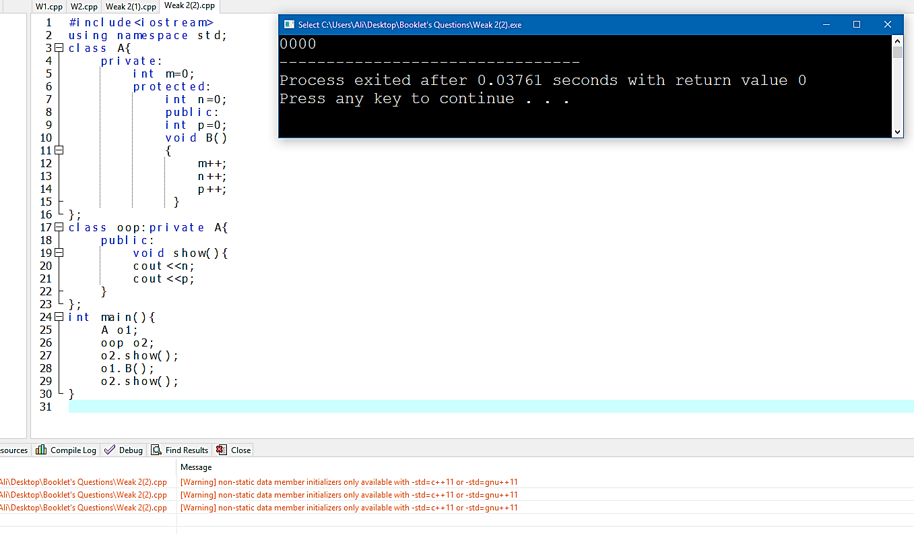**Output:**

**3-Program:**

**#include<iostream>**

**using namespace std;**

**class A{**

**public:**

**void show(){**

**cout<<"i love"<<"\t";**

**}**

**};**

**class B:public A{**

**public:**

**void display(){**

**cout<<"pakistan";**

**}**

**};**

**int main(){**

**B o1;**

**o1.show();**

**o1.display();**

**}**

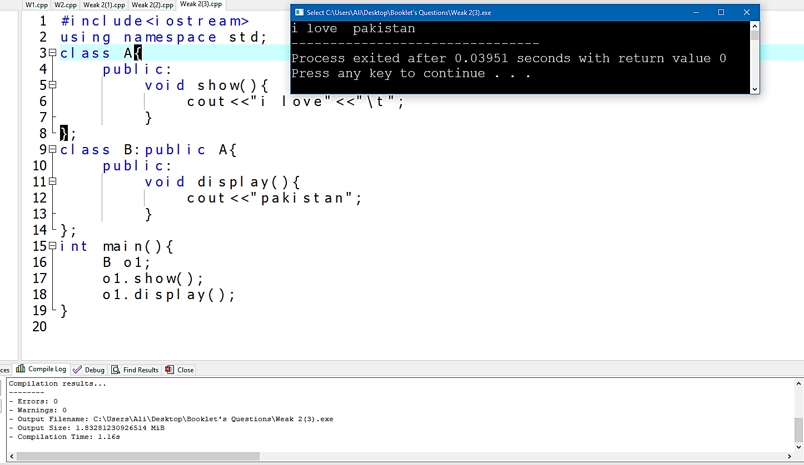**Output:**

**4-Program:**

**#include<iostream>**

**using namespace std;**

**class A{**

**public:**

**void show(){**

**cout<<"i"<<"\t";**

**}**

**};**

**class B:public A{**

**public:**

**void display(){**

**cout<<"pakistan";**

**}**

**};**

**class C:public B{**

**public:**

**void pro(){**

**cout<<"love"<<"\t";**

**}**

**};**

**int main(){**

**C o1;**

**o1.show();**

**o1.pro();**

**o1.display();**

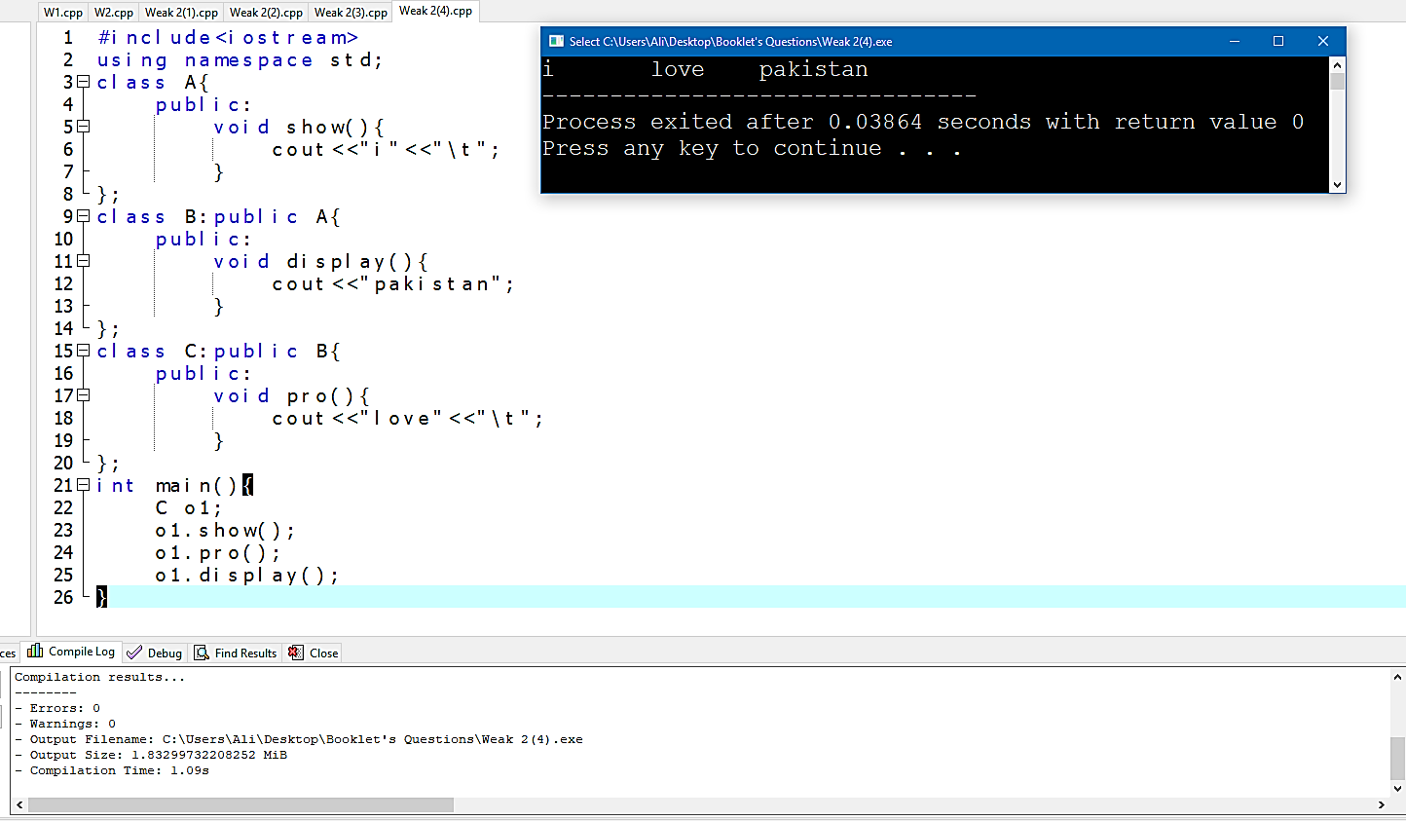**}Output:**

**5-Program:**

**#include<iostream>**

**using namespace std;**

**class A{**

**public:**

**void show(){**

**cout<<"is great"<<"\t";}**

**};**

**class B:public A{**

**public:**

**void display(){**

**cout<<"pakistan ";//"\t";}**

**};**

**class C:public A{**

**public:**

**void pro(){**

**cout<<"love ";//<<"\t";}**

**};**

**int main(){**

**C o1;**

**B o2;**

**o1.pro();**

**o1.show();**

**o2.display();**

**o2.show();**

**}**

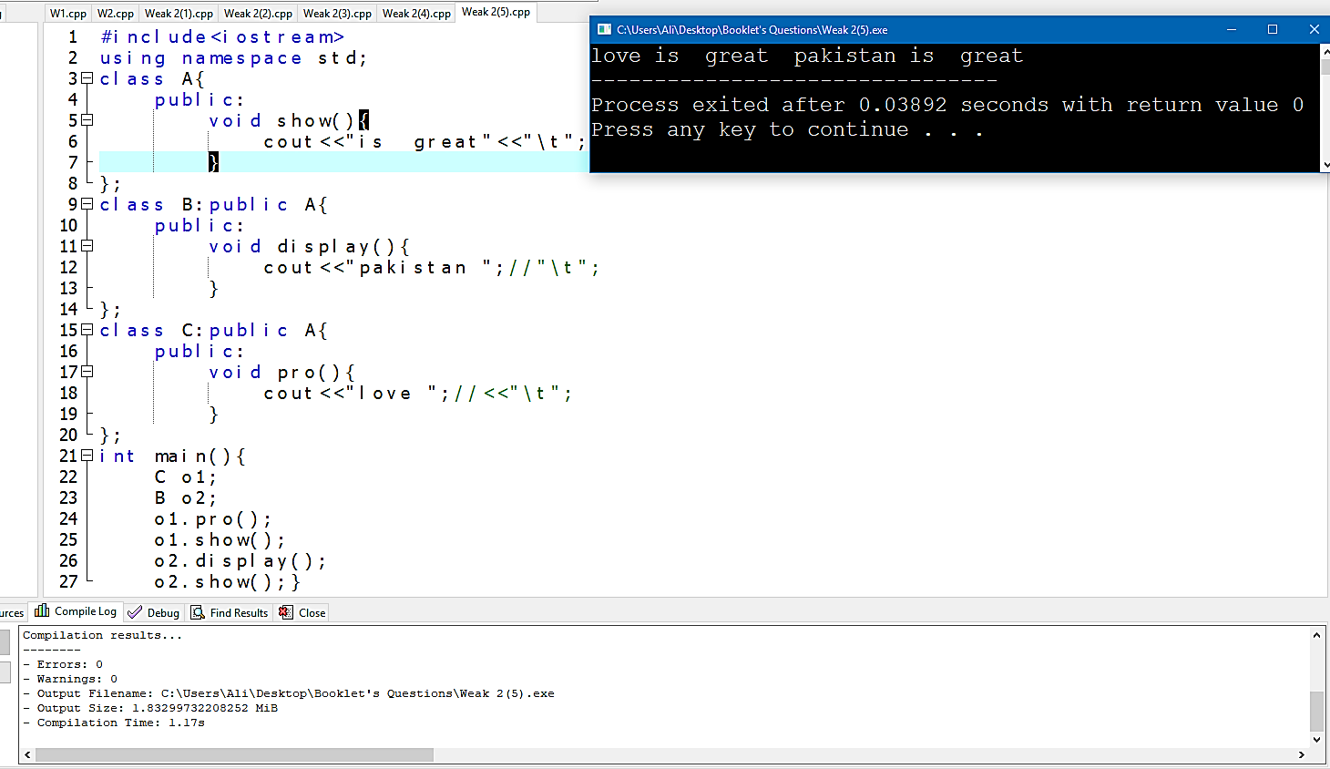**Output:**

**6-Program:**

**#include<iostream>**

**using namespace std;**

**class A{**

**public:**

**void show(){**

**cout<<"i"<<"\t"; }};**

**class B:virtual public A{**

**public:**

**void display(){**

**cout<<"Programming"<<"\t"; }};**

**class C:virtual public A{**

**public:**

**void pro(){**

**cout<<"love"<<"\t";}};**

**class D:public C,public B{**

**public:**

**void meh(){**

**cout<<"A"<<"\t";}};**

**int main(){**

**D o1;**

**o1.meh();**

**o1.show();**

**o1.pro();**

**o1.display();}**

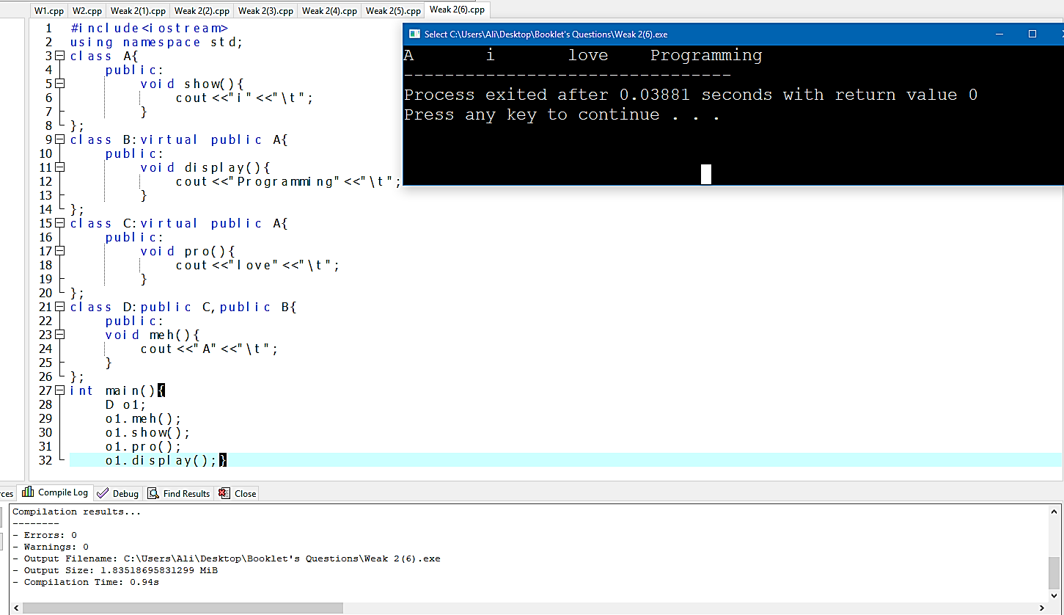**Output:**

**Week 3**

**1-Program:**

**#include<iostream>**

**using namespace std;**

**class A{**

**protected:**

**int a;**

**public:**

**A(){**

**a=10; }};**

**class B:public A{**

**private:**

**int b;**

**public:**

**B():A(){**

**b=20; }**

**void show(){**

**cout<<"a="<<a<<endl;**

**cout<<"b="<<b<<endl; }};**

**int main(){**

**B o1;**

**o1.show(); }**

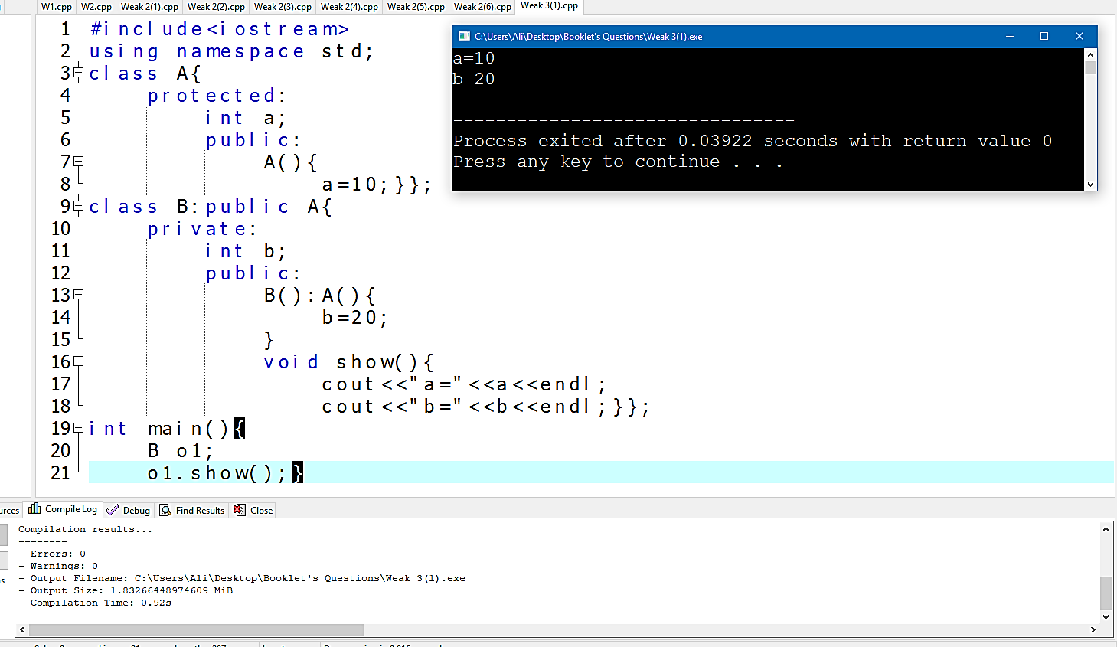**Output:**

**2-Program:**

**#include<iostream>**

**using namespace std;**

**class A{**

**protected:**

**int a;**

**public:**

**A(){**

**a=10; }**

**A(int x){**

**a=x; }};**

**class B:public A{**

**private:**

**char b;**

**public:**

**B():A(){**

**b='t'; }**

**B(char y,int m):A(m){**

**b=y;}**

**void show(){**

**cout<<"a="<<a<<endl;**

**cout<<"b="<<b<<endl;}};**

**int main(){**

**B o1('u',10);**

**o1.show(); }**

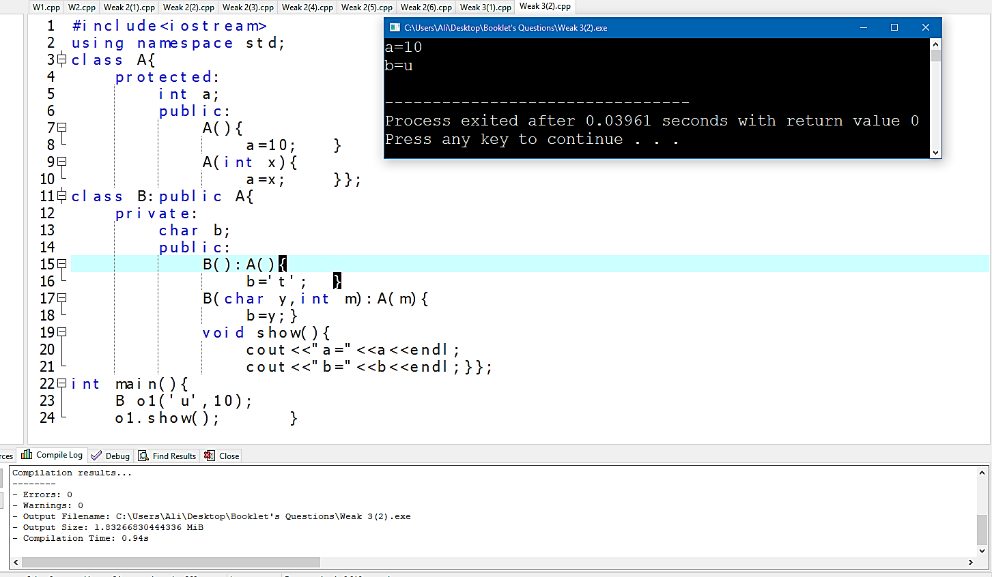**Output:**

**3-Program:**

**#include<iostream>**

**using namespace std;**

**class Parent{**

**private:**

**int n=10;**

**public:**

**void show(){**

**cout<<"n="<<n<<endl; }};**

**class child:public Parent{**

**private:**

**int b=15;**

**public:**

**void show(){**

**Parent::show();**

**cout<<"b="<<b; }};**

**int main(){**

**child o1;**

**o1.show(); }**

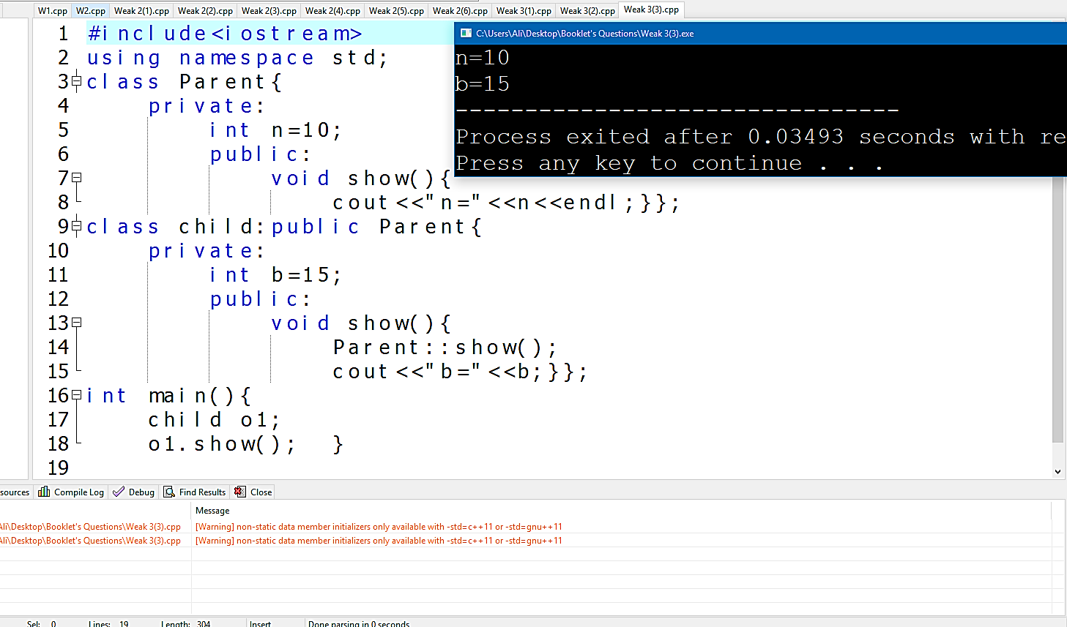**Output:**

**4-Program:**

**#include<iostream>**

**using namespace std;**

**class Parent{**

**private:**

**int n=10;**

**public:**

**void show(){**

**cout<<"n="<<n<<endl; }};**

**class child:public Parent{**

**private:**

**int b=15;**

**public:**

**void show(){**

**Parent::show();**

**cout<<"b="<<b<<endl; }};**

**class child1:public child{**

**private:**

**int c=20;**

**public:**

**void show(){**

**child::show();**

**cout<<"c="<<c; }};**

**int main(){**

**child1 o1;**

**o1.show(); }**

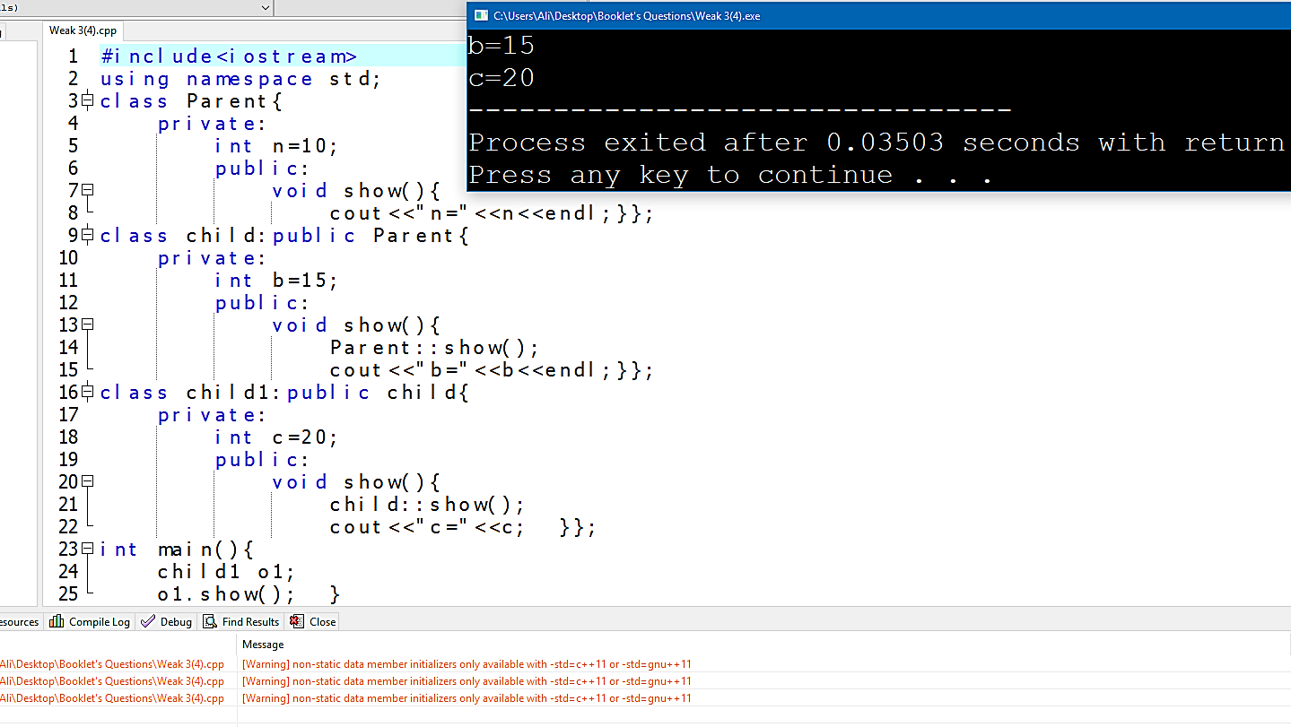**Output:**

**5-Program:**

**#include<iostream>**

**using namespace std;**

**class A{**

**public:**

**virtual void disp()=0;};**

**class B:public A{**

**int b;**

**public:**

**B(int x){**

**b=x;}**

**void disp()**

**{cout<<"Class B and b"<<b;}};**

**class C:public A{**

**int c;**

**public:**

**C (int x){**

**c=x;}**

**void disp(){cout<<"Class C and c="<<c;}};**

**int main(){**

**A *p;**

**B o1(10);**

**C o2(20);**

**p=&o1;**

**p->disp();**

**p=&o2;**

**p->disp(); }**

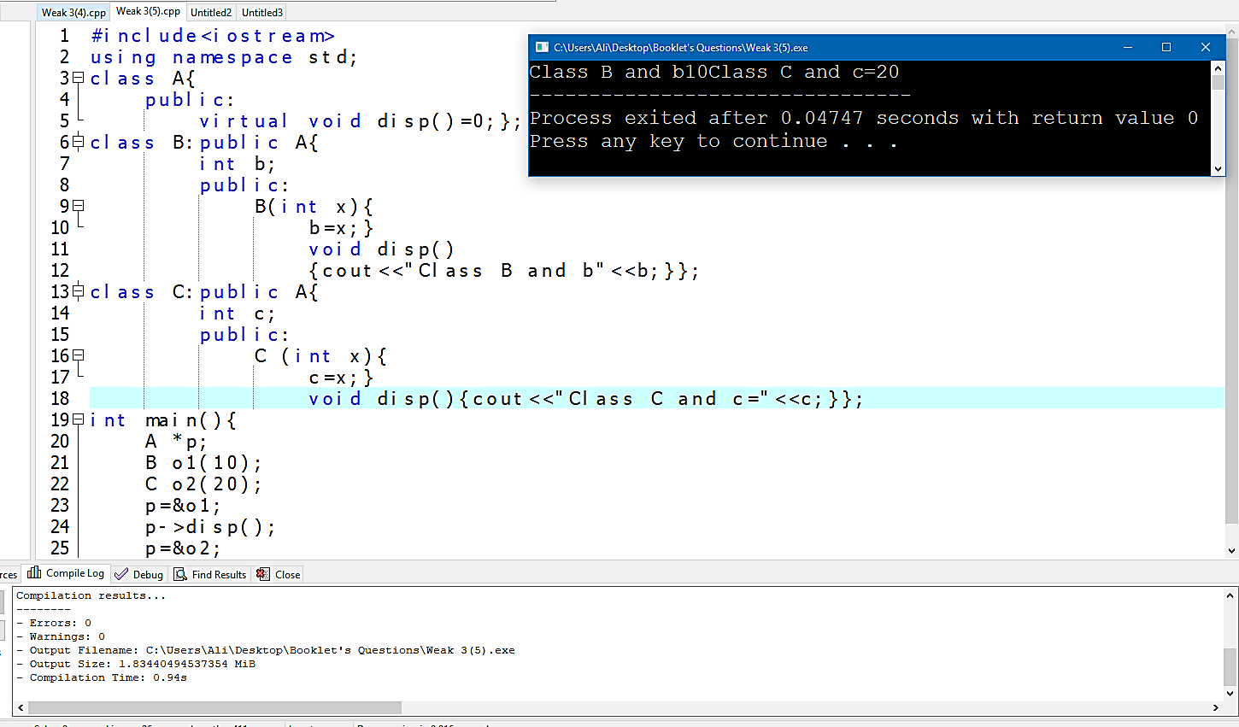**Output:**

**6-Program:**

**#include<iostream>**

**using namespace std;**

**class A{**

**private:**

**int a;**

**public:**

**A(int z){a=z;}**

**void show(){**

**cout<<a<<endl;}};**

**class B:public A{**

**private:**

**int b;**

**public:**

**B(int x , int m):A(m){b=x;}**

**void show(){**

**A::show();cout<<b<<endl;}};**

**class C:public B{**

**private:**

**int c;**

**public:**

**C(int y,int f , int h):B(f,h){c=y;}**

**void show(){B::show();cout<<c;}};**

**int main(){**

**C ob(12,23,34);**

**ob.show();}**

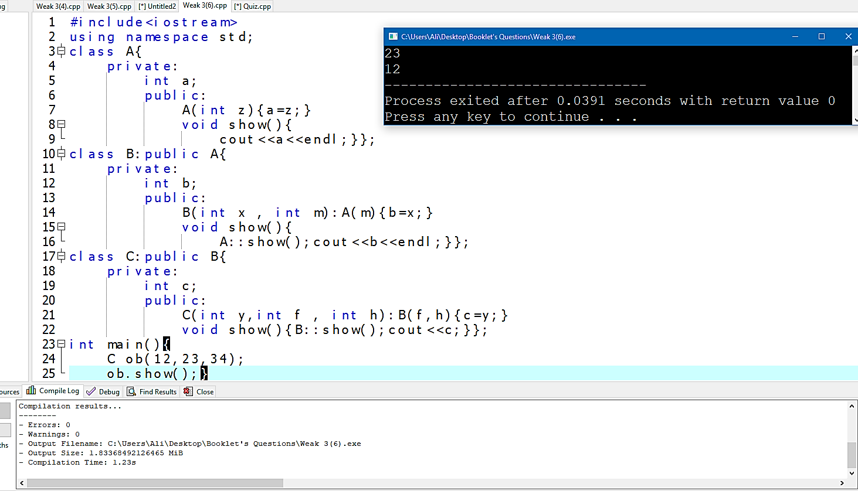**Output:**

**7-Program:**

**#include<iostream>**

**using namespace std;**

**class Base{**

**protected:**

**int a;**

**public:**

**Base(){a=10;}};**

**class Derived:public Base{**

**int b;**

**public:**

**Derived(){b=20;}**

**void show(){**

**cout<<a<<endl<<b<<endl;}};**

**int main(){Derived a1;a1.show();system("pause>0");}**

**Output:**

